1. Propaedeutic Digital Design

“Basics of electronics”

Hi students,

There are two books available on internet for free that I use in this course and I recommend you widely:

1. Digital Systems Principles and Applications. Ronald J. Tocci. 10th Ed. [1]
2. Digital design With an Introduction to the Verilog HDL. F5th Ed. M. Morris Mano [2]

Please find help in those books and answer the following questions using your own words. Send your answers in private message today all day long.

1. What is a computer?
2. What is a program?
3. Why we use digital computers instead analog computers? Give some advantages or disadvantages as you consider.
4. Which semiconductor device is the basis of a digital component?
5. Explain and draw the following circuits:
   1. Turn on a LED using 87 VDC. Use the common working current of a LED of 20 mA.
   2. Turn on 2 LEDs connected in parallel using 12 VDC.
   3. Turn on as many LEDs as you can connected in series using 12VDC.
   4. Turn on a LED using a common NPN bipolar transistor using a 12 VDC power supply for the LED and a 5 VDC as a trigger pulse; when the pulse is at the high level, the LED turns on and when the pulse is at low level, the LED is turned off.
   5. Do the opposite working circuit as in the letter <d>; LED is ON when pulse is LOW and LED is OFF when pulse is HIGH. Same function as a NOT gate.
6. BASICS OF COMBINATIONAL LOGIC CIRCUITS

Hi students,

Please answer the next problems in a word document (full_student_name.docx) and send it to me by private message. Revision date: June 22th all day long.

Please review the figure 3-16 of the book “Digital Systems Principles and Applications. Ronald J. Tocci” Tocci. 10th Ed.

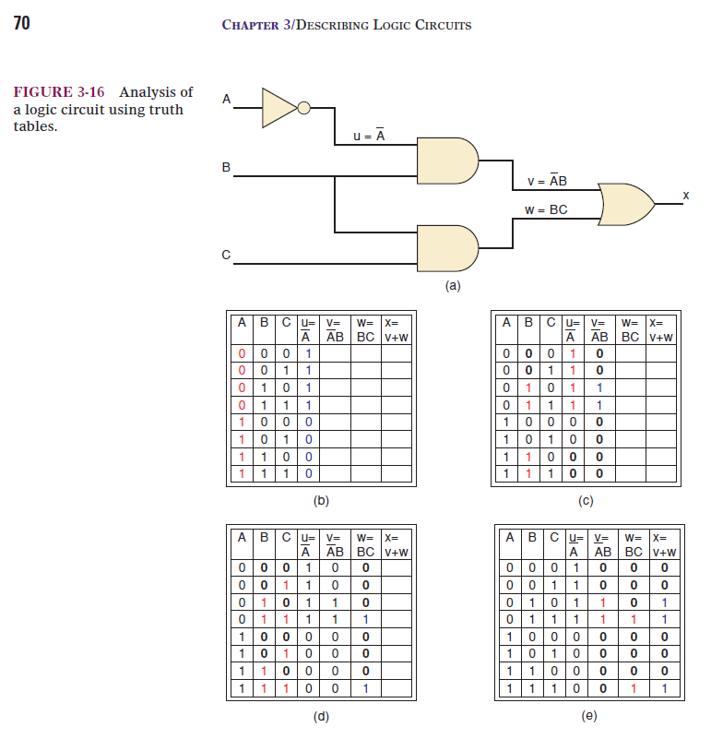

1. Draw the following circuits and get the truth table of each one:
2. A’BC + AB’C + ABC’
3. A’B + AB’
4. A XOR B XOR C
5. Write the following expressions as Sum of Products (SOP) or Product of sums (POS) as appropriate.
6. A’B + AB’
7. (A+B)(A’+B’)
8. A’B’C + A’BC’ + AB’C’ + ABC
9. (A+B+C)(A+B’+C’)(A’+B+C’)(A’+B’+C)
10. Program the Truth Table (TT) of any expression. The output will show up in the screen as in figure 3-16 or in figure 3-17. Considerations:
11. The student chooses the programming language.
12. It is widely recommendable that the student designs the algorithm using flow-charts before programming.
13. The student chooses the number of input variables (A, B, C, etc.)
14. The student chooses the input way and everything else as necessary. For instance, If the input will be whether in POS or SOP.



Figure 3-7 Example of an output of a code in C

1. Combinational Logic

On the next link, you will be able to find both books [1] and [2].:

<https://www.dropbox.com/sh/gtfydeqe8vk5j5n/AACT3-NILCxtx3V-IVY5nDQpa?dl=0>

Please read the section related to decoders and solve the next exercises in a word document (full_student_name_4.docx) and send it to me by private message:

1. Get the truth table of a common anode 7-segment display
2. Get the truth table of a common cathode7-segment display.
3. Get the output equation (Anode and Cathode) of each segment: A, B, C, D, E, F, G and DP.
4. For each input code <X3:X0> give the output in hexadecimal <A:DP>|

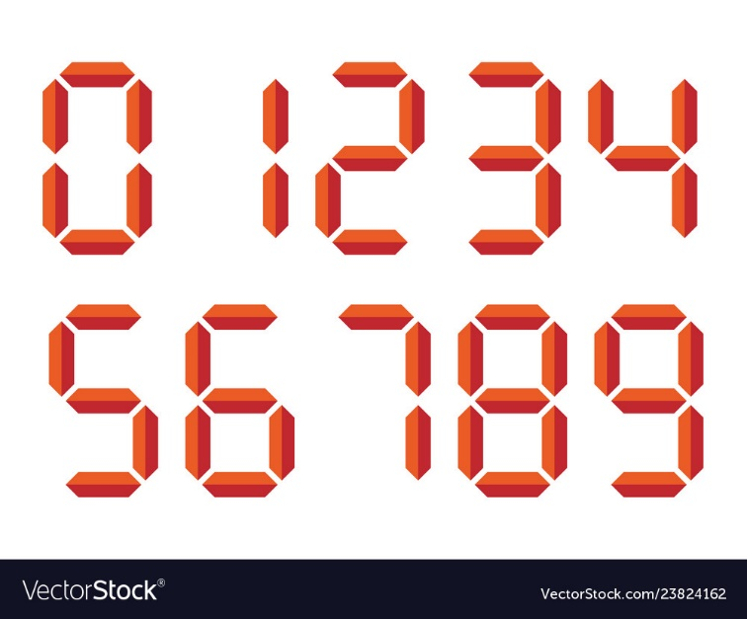 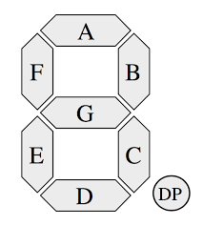

|  |  |  |  |  |  |  |  |  |  |  |  |  |  |  |
| --- | --- | --- | --- | --- | --- | --- | --- | --- | --- | --- | --- | --- | --- | --- |
| **Display** | **Inputs** | | | |  | **Outputs Cathode** | | | | | | | | **HEX** |
| **Number** | **x3** | **x2** | **x1** | **x0** |  | **a** | **b** | **c** | **d** | **e** | **f** | **g** | **dot** |  |
| 0 | 0 | 0 | 0 | 0 |  | 1 | 1 | 1 | 1 | 1 | 1 | 0 | 0 | *0XFC* |
| 1 | 0 | 0 | 0 | 1 |  |  |  |  |  |  |  |  |  |  |
| 2 | 0 | 0 | 1 | 0 |  |  |  |  |  |  |  |  |  |  |
| 3 | 0 | 0 | 1 | 1 |  |  |  |  |  |  |  |  |  |  |
| 4 | 0 | 1 | 0 | 0 |  |  |  |  |  |  |  |  |  |  |
| 5 | 0 | 1 | 0 | 1 |  |  |  |  |  |  |  |  |  |  |
| 6 | 0 | 1 | 1 | 0 |  |  |  |  |  |  |  |  |  |  |
| 7 | 0 | 1 | 1 | 1 |  |  |  |  |  |  |  |  |  |  |
| 8 | 1 | 0 | 0 | 0 |  |  |  |  |  |  |  |  |  |  |
| 9 | 1 | 0 | 0 | 1 |  |  |  |  |  |  |  |  |  |  |
| A | 1 | 0 | 1 | 0 |  |  |  |  |  |  |  |  |  |  |
| B | 1 | 0 | 1 | 1 |  |  |  |  |  |  |  |  |  |  |
| C | 1 | 1 | 0 | 0 |  |  |  |  |  |  |  |  |  |  |
| D | 1 | 1 | 0 | 1 |  |  |  |  |  |  |  |  |  |  |
| E | 1 | 1 | 1 | 0 |  |  |  |  |  |  |  |  |  |  |
| F | 1 | 1 | 1 | 1 |  |  |  |  |  |  |  |  |  |  |

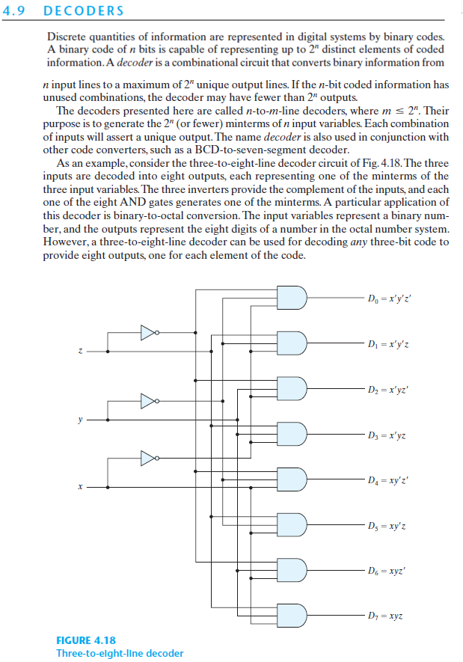

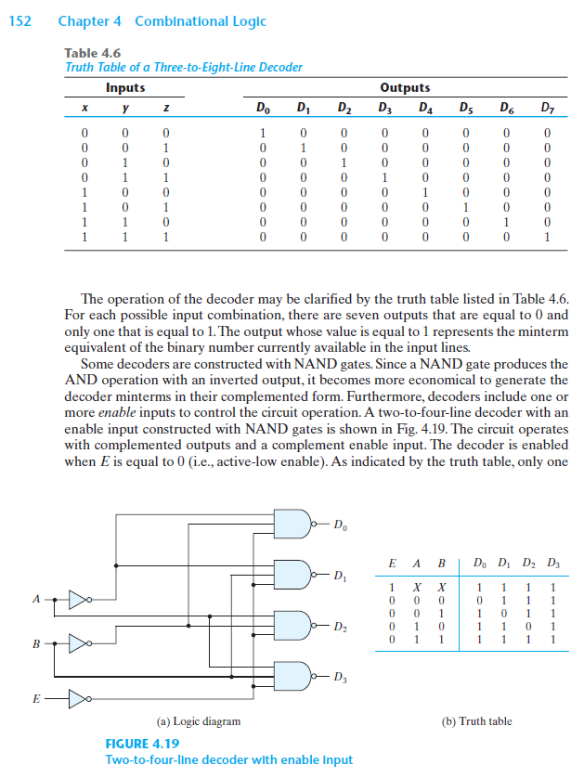

1. Multiplexers
2. Please read and describe using your own words all the elements that you need in order to create a 8:1 Multiplexer. Draw the Logic Diagram and Write the output equation.
3. Implement the next Boolean function using a multiplexer:

X(A,B,C,D) = Minterms(0, 4, 5, 9, 10, 11, 14, 15)

Get the equation of “X”.

Note: Please Respect the notation (The variables A, B, C, D, X) as indicated.

Hi everyone,

Please read and do the exercises related to “Multiplexers” of the section 4 of the document “Digital Design propaedeutic.docx” The document is available on the link that I gave you previously.

These exercises are a **requirement** for your first exam. Please do them.

Revision date: Today –Friday, July 3, 2020 all day long.

Exam date: Monday, July 6, 2020 at 15h00. Duration: 02h00. Please study.

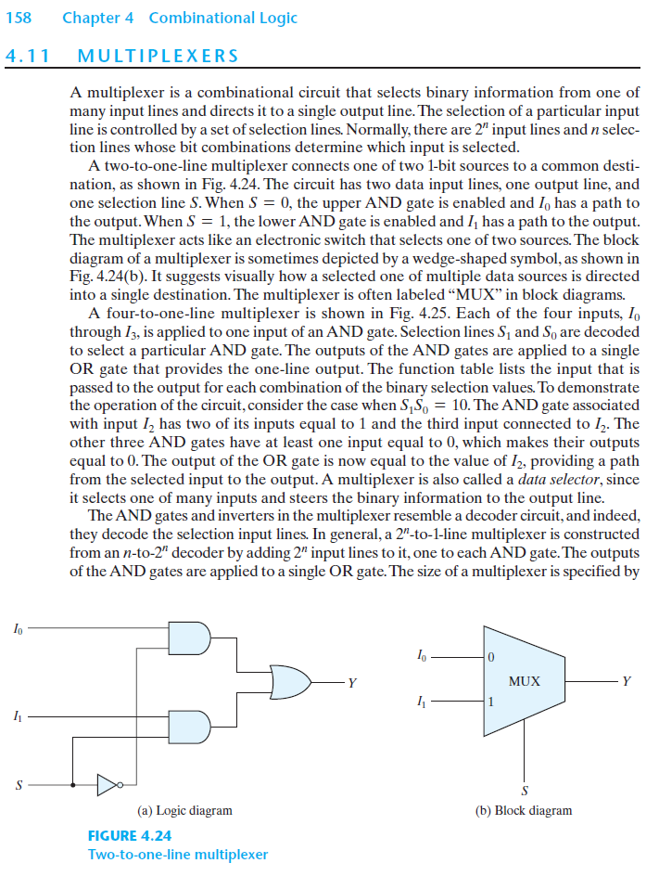

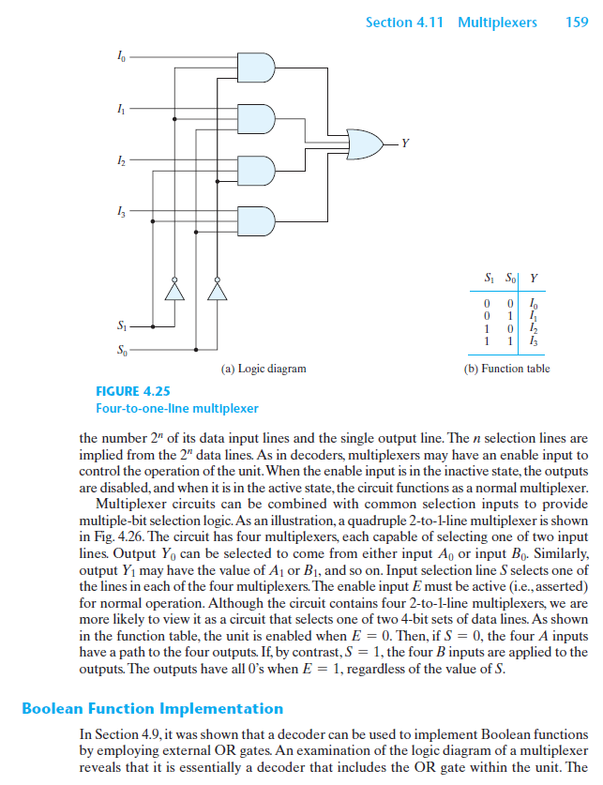

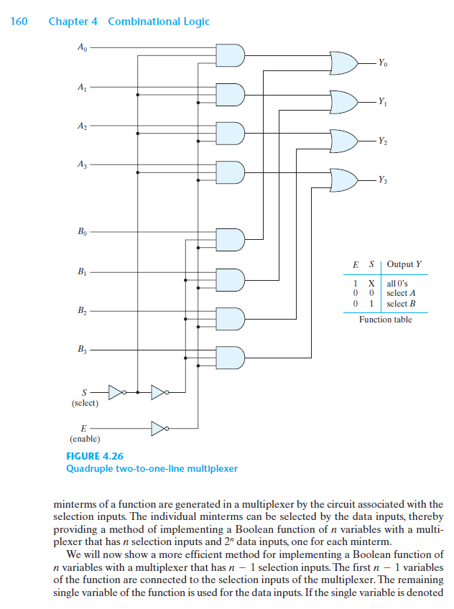

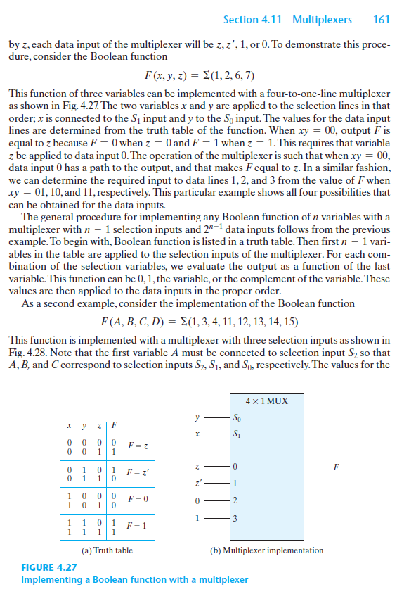

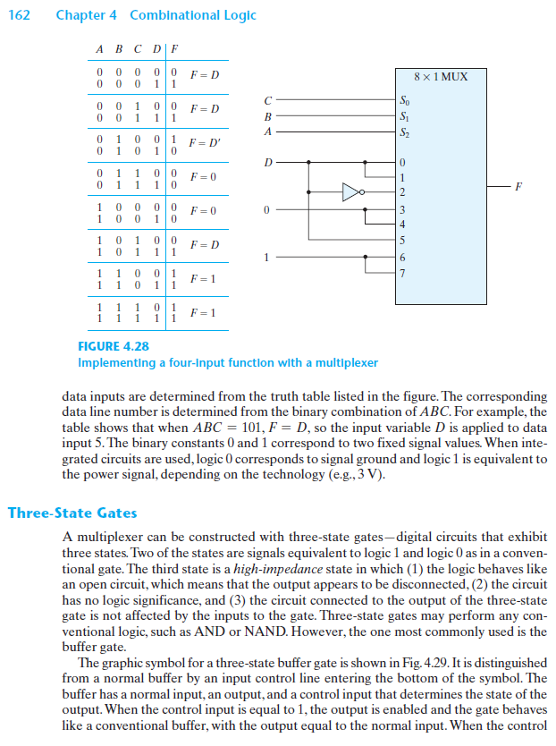

Exam

**Instructions: please answer the following questions in a word document (No images, No PDF), name it as “full_student_name_exam1.docx” and send it to me as private message.**

**Important: Do not change any variable name.**

1. Suppose that you have a power supply of 12VDC. Design just one Resistor-array to get 3VDC, 5VDC, and 9VDC.
2. Get the truth table, the reduced equation **in SOP form** and the circuit of the function:

X(A, B, C, D, E) = **Minterms**(0, 5, 6, 9, 11, 12, 15)

1. Implement the next Boolean function using a multiplexer and draw the final circuit using the multiplexer:

X(A,B,C,D) = **Maxterms**(1, 2, 3, 7, 11, 12, 14)

Get the equation of “X” in **POS form.**

A FLIP-FLOP is a storage element that works with pulses. See Table 5.1 and figure 5.11.

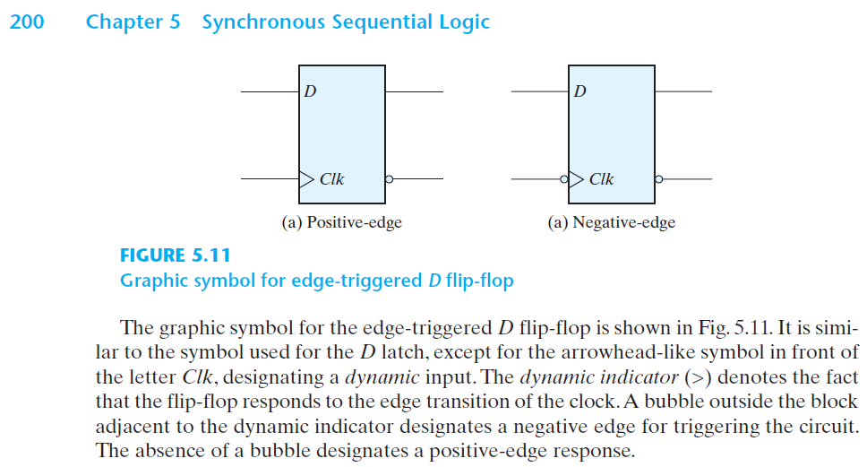

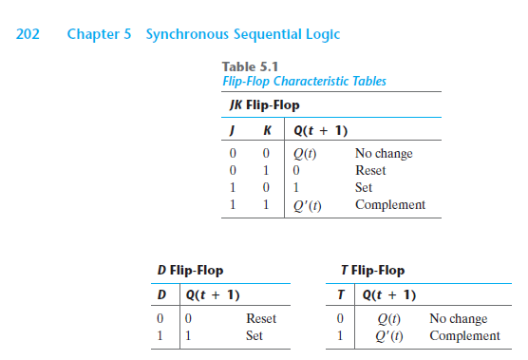

1. Get the equation of each Multiplexer shown in figure 6.7

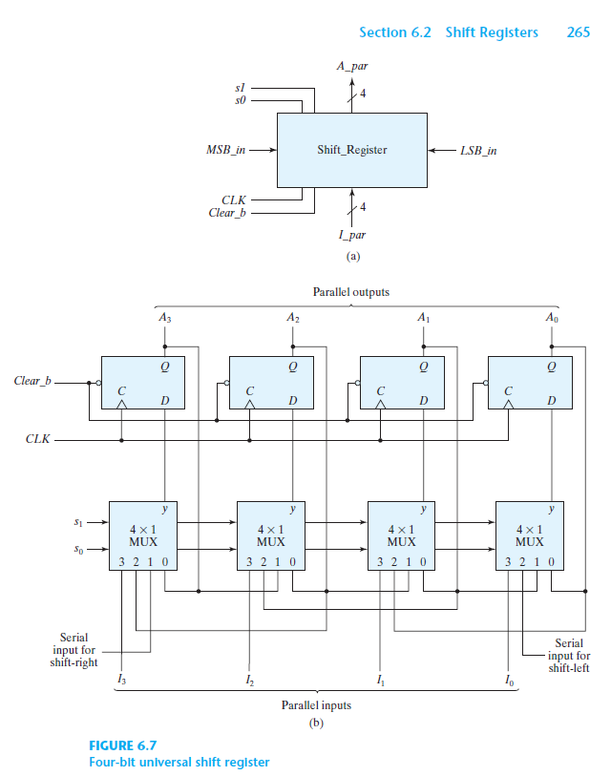

0 = MEMORY

1 = SHIFT RIGHT

2 = SHIFT LEFT

3 = PARALELL LOAD

MUX0 = S1’ S0’ A0 + S1’ S0 A1 + S1 S0’ L + S1 S0 I0

MUX1 = S1’ S0’ A1 + S1’ S0 A2 + S1 S0’ A0 + S1 S0 I1

MUX2 = S1’ S0’ A2 + S1’ S0 A3 + S1 S0’ A1 + S1 S0 I2

MUX2 = S1’ S0’ A3 + S1’ S0 R + S1 S0’ A2 + S1 S0 I3

1. Flip Flop
2. From Flip-Flop D, get the truth table / equation of JK and T Flip-Flops. See figures from 5.11 and so on.
3. Design an upward synchronous counter like 0,1,2,3,4,5,6,7 and repeat again from 0.

Use D Flip-Flop.

Revision Date: Wednesday July 8, 2020 before 18h00.

Send it to me as “Full_name_FlipFlop.docx”

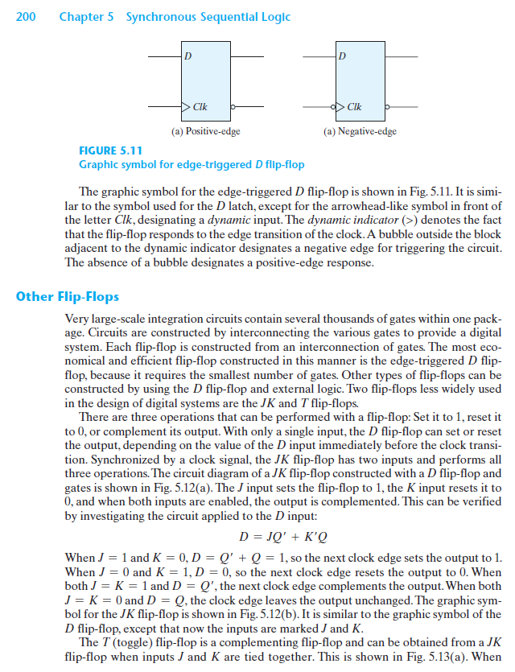

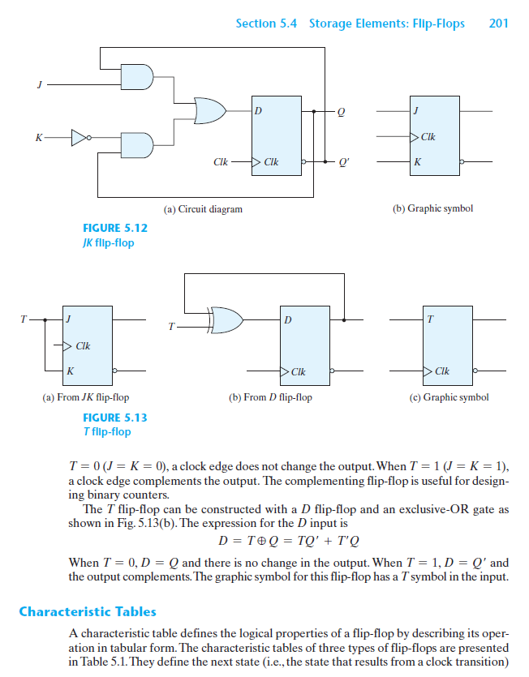

Final Exam

Please Get the reduced equations of each bit of the following situation:

Taking “X” as selector and using FF-D:

If X = ‘0’, count upward from 0, 1, 2, 3, 4, 5, 6, 7 and repeat.

If X = ‘1’, count upward from 1, 2, 3, 8, 9, 15 and repeat.

Note: write B0 as the least significant bit. Use as many bits as necessary, for instance:

<Bn, Bn-1 …, B1, B0>

Revision date: Today Friday, July 10, 2020. The latest at 20h30.

Send me your exam as private message> “full_name_finalExam.docx”.

